**JIRA**

**Road Map:**

A road map is a strategic plan that defines a goal or desired outcome and

includes the major steps or milestones needed to reach it. It also serves as a

communication tool, a high-level document that helps articulate strategic thinking—the why—behind both the goal and the plan for getting there.

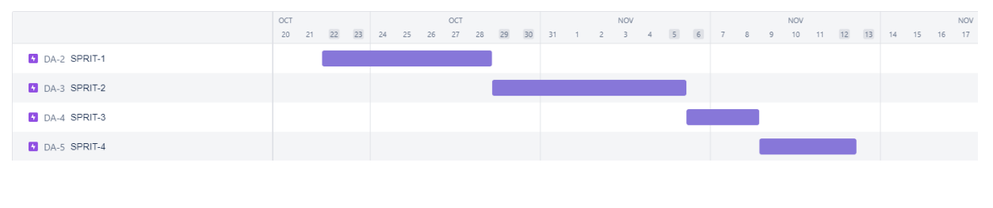

**Kan ban Board:**

A kan ban board is an agile project management tool designed to help

visualize work, limit work-in-progress, and maximize efficiency (or flow). It can help both agile and Develops teams establish order in their daily work.

**BURNDOWN CHART**

